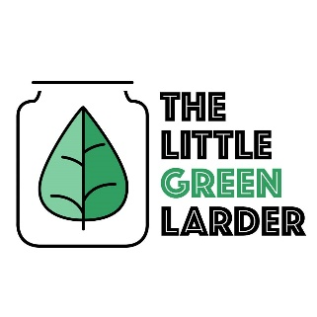

The Little Green Larder

Vegan chilli, guacamole and rice

Serves 2

Chilli ingredients Guacamole ingredients  
Chopped tomatoes Tomato  
¾ Onion Avocado  
Carrot 1 – 2 cloves garlic  
Kidney and black eye Beans Lime   
Chick peas ½ Chilli  
½ chilli ¼ onion  
Spice mix  
2 – 4 cloves garlic  
Rice

- Soak chickpeas and beans for 4 – 8hours (we just leave them overnight), rinse then place in a pot of water. Bring to boil then simmer for 1 hour. Drain and set aside

- Chop onion, 4 - 6 cloves of garlic, chilli and carrot. fry 2 – 4 cloves garlic, 3/4 onion and spices in oil for 2 – 4 minutes. (add ½ chilli for extra spice) Add carrots and fry for a further 5 minutes.

- Add chickpeas, beans and the can of chopped tomatoes, cook for 20 – 30 minutes, salt and pepper to taste and serve with rice

- for guacamole mash the avocado, mix with 1 – 2 garlic cloves, the other ¼ of the onion, chopped fresh tomatoes, the other ½ of the chilli and squeeze ½ of the lime juice in. Salt and pepper to taste